**Unable to do pip install boto3 on Unbuntu environment on windows**.

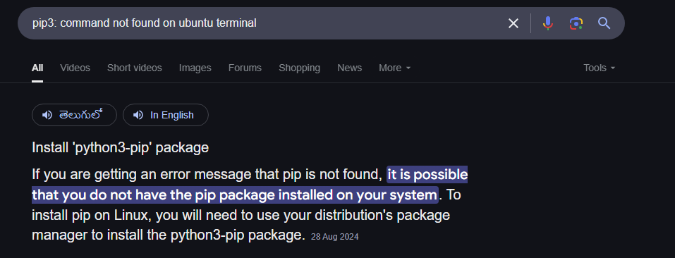

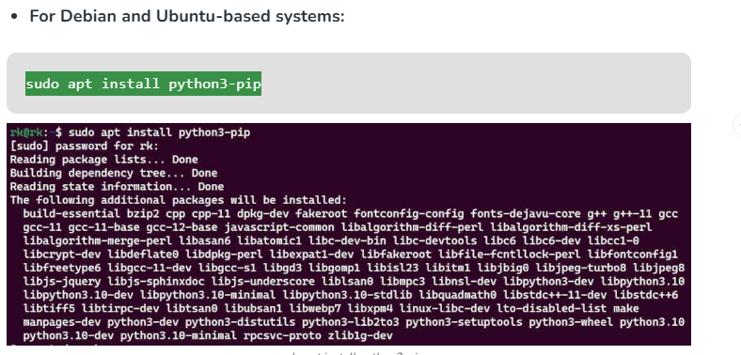

Still not able to pip install boto3.

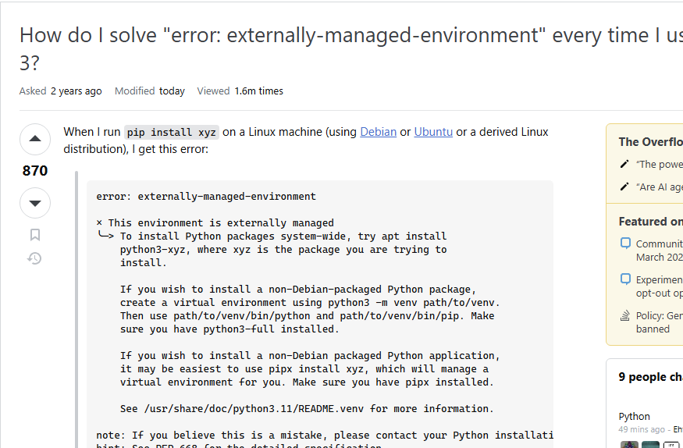

Solution - <https://stackoverflow.com/questions/75608323/how-do-i-solve-error-externally-managed-environment-every-time-i-use-pip-3>

Either you have to create virtual environment or set the variable as below

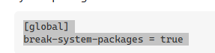

Set the variable is not recommended by the article.

Tried creating virtual environment. Got the below error.

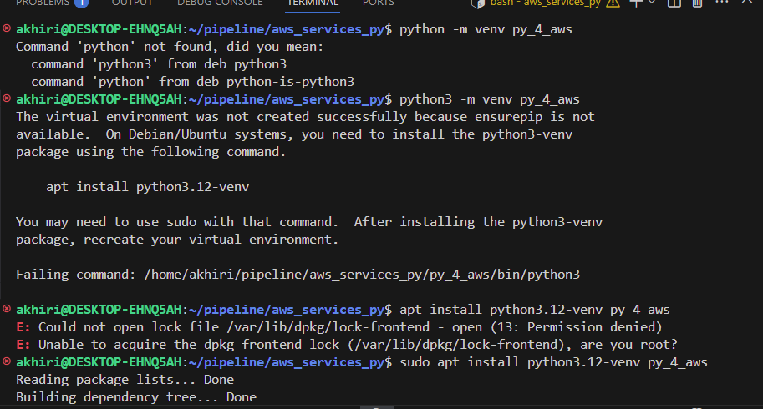

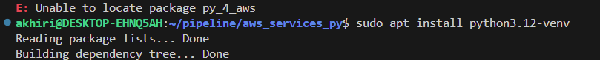

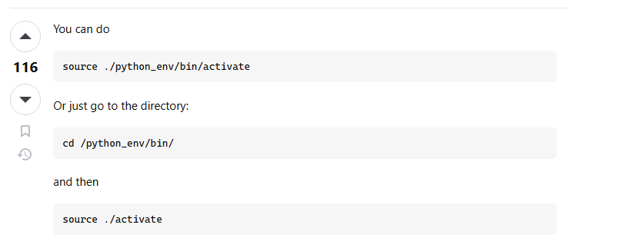

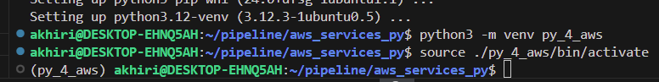

Installation of boto3 worked.

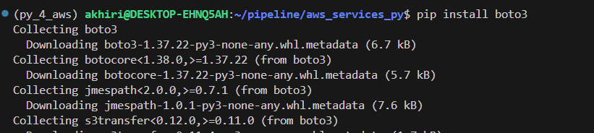

Error when creating the s3 bucket.

